America's Forgotten History Of Mexican-American 'Repatriation'
September 10, 2015
Heard on Fresh Air
https://www.npr.org/2015/09/10/439114563/americas-forgotten-history-of-mexican-american-repatriation
With a scarcity of jobs during the Depression, more than a million people of Mexican descent were sent to Mexico. Author Francisco Balderrama estimates that 60 percent were American citizens.
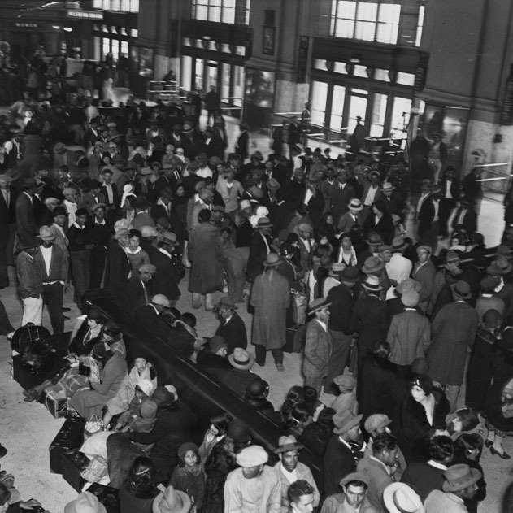

Mass Deportation May Sound Unlikely, But It's Happened Before
TERRY GROSS, HOST:
This is FRESH AIR. I'm Terry Gross. Donald Trump has proposed immigration reform that would include building a wall on the Mexican border, paid for by Mexico, and calls for the mass deportation of immigrants who are in the U.S. illegally. The deportation plan has echoes of a largely forgotten chapter of American history when, in the 1930s, during the Depression, about a million people were forced out of the U.S. across the border into Mexico. It wasn't called deportation. It was euphemistically referred to as “repatriation”, returning people to their native country. But about 60 percent of the people in the Mexican repatriation drive were actually U.S. citizens of Mexican descent. Perhaps the most widely cited book on the subject was co-written by my guest, Francisco Balderrama. The book is called "Decade Of Betrayal: Mexican Repatriation In The 1930s." His late co-author, Raymond Rodriguez, had family that was forced out of the U.S. Balderrama is a professor of American history and Chicano studies at California State University, Los Angeles. Francisco Balderrama, welcome to FRESH AIR. Would you give us an overview of the scope of the mass deportations or the repatriation of the 1930s? Like, how many people were affected? And of those people, how many of them were actually American citizens?
FRANCISCO BALDERRAMA: Well, conservatively, we're talking about over 1 million Mexican nationals and American citizens of Mexican descent from throughout the United States, from the American Southwest to the Midwest to the Pacific Northwest to the South, even Alaska included. This occurred on a number of different levels through a formal deportation campaign at the federal government, then also efforts by major industries as well as efforts on the local and state level. Conservatively, we are able to estimate that 60 percent of them were U.S. citizens of Mexican descent.
GROSS: So what was behind these deportations? Was it the Depression?
BALDERRAMA: Well, the Depression set the scenario for what happened. I think one needs to keep in mind that in the American public at that time, Mexicans were targeted as a scapegoat partly because they are the most recent immigrant group to come to the United States in the early 20th century.
GROSS: So what did the order for deportation actually say?
BALDERRAMA: Well, the deportation, key to keep in mind...
GROSS: This was a federal law, or there were local laws and federal laws?
BALDERRAMA: There was not a federal deportation act, even though in some of the literature, it makes reference to that. That did not occur. What one has to be sensitive to in order to understand this history, is that it occurred in different forms. During the Hoover administration in the late 1920s and early 1930s, particularly the winter of 1930-1931, William Dill, the attorney general who had presidential ambitions, announced that we needed to provide jobs for Americans, and so we need to get rid of these other people. This created an anxiety, a tension in the Mexican community. And at the same time, U.S. Steel, Ford Motor Company, and the Southern Pacific Railroad said to their Mexican workers, “you would be better off in Mexico with your own people”. At the same time that that's occurring, differing counties - on the county level in some cases the state level - then decide to cut relief costs - their target at Mexican families.
GROSS: Relief is welfare. That's what welfare was called.
BALDERRAMA: Yes, yes, at that time it's called - and charities at that time as well. Now, there was the development of a deportation desk from LA County relief agencies going out and recruiting Mexicans to go to Mexico. And they called it the deportation desk. Now, LA legal counsel says you can't do that. That's the responsibility, the duty, of the federal government. So they backed up and said, well, we're not going to call it deportation. We're going to call it repatriation. And repatriation carries connotations that it's voluntary, that people are making their own decision without pressure to return to the country of their nationality. But most obviously, how voluntary is it if you have deportation raids by the federal government during the Hoover administration and people are disappearing on the streets? How voluntary is it if you have county agents knocking on people's doors telling people oh, you would be better off in Mexico and here are your train tickets? You should be ready to go in two weeks. So...
GROSS: Is that what happened?
BALDERRAMA: That's what happened.
GROSS: So what were some of the ways that Mexicans in the U.S. were pressured to leave?
BALDERRAMA: Well, they were pressured by county agents, sometimes from relief agencies knocking on their door and telling Mr. and Mrs. Gonzales that you would be better off in Mexico where you can be with your own people and speak your own language. We have arranged for train tickets. You can take so many boxes or suitcases with you. Would you please show up at the train station in two weeks? And sometimes it extended beyond those that were on relief. Sometimes families that did have individuals that were working maybe limited time, which was very common during the Great Depression, but scaring them and telling them well, I don't know how long you're going to keep that job. Maybe you better just go to Mexico because you're liable to lose that particular job. And I think another factor is just waking up and looking at the newspaper, seeing that there's raids. Here in Los Angeles, we had the very famous Placita raid, in which a part of Downtown Los Angeles is cornered off, and there's banner headlines saying, deportation of Mexicans - not distinguishing between those with papers and not distinguishing those that are American citizens but always just referring to Mexicans and deportation of Mexicans and not making any of those distinctions. Those are the pressures that this population lived with.
GROSS: You mention a part of Los Angeles that was cordoned off. Would you explain?
BALDERRAMA: Downtown Los Angeles around the area of the LA Plaza next to Olvera Street right across from, today, Union Station, near Our Lady Queen of the Angels Church. That particular area was cornered off February 26, 1931 - very different approach of the Immigration and Naturalization Service, who had not planned to do that until the unemployment coordinating committee in LA County announced that raids were going to happen in Los Angeles and then after the fact, informed Washington D.C. about that. And then they followed suit and had raids in Pacoima and San Fernando Valley. But the one here in Los Angeles received a great deal of publicity because it was cornering off a popular area of the city and even rounded up a Mexican vice consul and had him in custody as well. Now, the raid itself didn't net that many people that were deported. But more significantly is those are the banner headlines - that here in Los Angeles, the historic founding of Los Angeles, this great Mexican city, this is what happened. And with that, then we have days and weeks that many Mexicans are not visible publicly because they're afraid of these raids that are occurring.
GROSS: So the programs officially targeted Mexicans who did not have citizenship in the U.S. and didn't have working papers, but citizens ended up...
BALDERRAMA: On the federal level.
GROSS: On the federal level.
BALDERRAMA: On the federal level. But in terms of the American society, it was really - the question or issue of documentation or papers really wasn't being raised that much. It was really about the idea that the Mexicans should go back. And many groups thought that they were doing really a very humane thing. And it was explained in terms of, well, they'd be better off with their own people where they can speak their own language. But it did take different forms. I'm thinking of the case of Ignacio Pena. And Ignacio lived in the area of Idaho. And his family was about to sit down to have breakfast. And the sheriffs came to the house. They took everybody into custody, and they were told that they could only leave with the clothes that were on their back. They could not bring any of their personal belongings, and they were placed in a jail. His father was working out in the fields, and he was also placed in a jail. They stayed in that jail - he with his mother and his brothers and sisters in one cell and his father in a separate part of the jail. They were placed on trains after a week, and then they were shipped to Mexico. They never were able to recover their personal belongings, even though they were told that those belongings were - would be shipped to them. And among those belongings was a documentation of his father having worked in the United States for over 25 years. Among those belongings was his and his sisters' and his brothers' birth certificates, having been born in the United States.
GROSS: So these raids that you referred to, did authorities raid farms where there were migrant workers? Did they raid other places where they thought Mexicans might be working?
BALDERRAMA: Some of these raids did occur. But as we go further into the 1930s, really it's businesses operating in terms of trying to cut their workforce or shipping workers, with their own resources, to the border. And it's also local county agencies and individual states that are also doing it. A particular factor to keep in mind is that this operation of businesses doing this and local county governments doing this are much acting like a sovereign power because the right and the responsibility of doing this rests with the Border Patrol and the Immigration and Naturalization Service. But the federal government, whether it be the Hoover administration or whether it be Franklin D. Roosevelt and the New Dealers, they're not concerned about that. They let these local agencies and businesses go ahead and do this.

Comprehension and Analysis:
In what ways could one say that the federal government was complicit in the Mexican Repatriation, even without a federal deportation act? What parallels can you see in today’s America?
________________________________________________________________________________________________________________________
________________________________________________________________________________________________________________________
________________________________________________________________________________________________________________________
________________________________________________________________________________________________________________________
________________________________________________________________________________________________________________________
________________________________________________________________________________________________________________________
________________________________________________________________________________________________________________________
________________________________________________________________________________________________________________________
________________________________________________________________________________________________________________________
________________________________________________________________________________________________________________________
________________________________________________________________________________________________________________________
________________________________________________________________________________________________________________________
________________________________________________________________________________________________________________________
________________________________________________________________________________________________________________________

