Historical Mythbusting #3
The Primitive Savage Myth: Ancient Native American tribes were so primitive that they never attained the agricultural or technological sophistication of other ancient peoples. Thus, when European settlers arrived in the "New World", they encountered bands of primitive, uncivilized, savages.
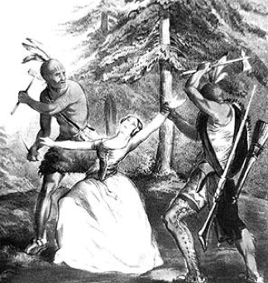
Historical evidence indicates that many Indian tribes had attained impressive levels of agricultural, cultural, and/or technological sophistication prior to the "discovery" of the "New World" by Europeans. Indeed, when European settlers arrived, between 500-600 separate tribal societies existed in North America, most of which were highly civilized in terms of their political, economic, social, and spiritual development. Each society had developed the capacity for unified action, had learned how to adapt to their natural environment, had achieved some sense of group identity and ethnic pride, and had created its own system of family and social organization.
Most tribes were, in fact, technologically, agriculturally, and politically sophisticated. Most lived in settled (rather than nomadic) communities that were highly developed. Such tribes shared the following characteristics:
- Division of labor among men, women and children
- Solid subsistence base
- Economic, social, cultural, political, and spiritual diversity
- Hierarchical organization
- Environmental adaptation to their natural environments
- Broad networks of diplomacy, trade and alliances across the Continent

