Historical Mythbusting #2 (alternate)
Virgin Wilderness Myth: When the European settlers arrived, they found a people untouched by civilization.

Before Europeans arrived, the indigenous peoples had already altered the environment in one significant way – mound building.
Mound building. About 800 years ago, the lower Mississippi Delta was home to some of the most highly organized civilizations in the world - civilizations that lived in cities anchored by incredible earthen monuments which we now call mounds. If you look at this http://users.humboldt.edu/ogayle/hist110/Mississippian_cultures.jpgmap of the confluence of the Missouri and Mississippi Rivers, you can see the large number of regional settlements with mounds that existed by the 1200s.
  - The Mississippians who lived in this region built dozens - and perhaps thousands - of mounds across the Delta and the southeast when Europeans were living through the Middle Ages and the Renaissance.
  - The largest and most sophisticated of these mound-building societies was Cahokia - located in the 80-mile long floodplain at the confluence of the Mississippi and Missouri rivers.
    - Between 800-600 BC, hunter-gatherers set up temporary camps or seasonal villages in the region.
    - As more intense farming methods and diverse crops were grown between AD 1050-1150, its population soared to around 20,000. By 1250, Cahokia was larger than London. There was no larger North American city until 1800 when Philadelphia's population reached 30,000.
    - Cahokia was twice as densely populated (about 4,000 persons per square mile) as current day Los Angeles County (2,200 per square mile.)
    - Archaeological studies suggest that at the height of its influence, Cahokia was the largest and most important settlement north of Mexico. Cahokian artifacts and pottery found in many regions indicate that merchants traded with cultures extending from the Gulf Coast to the Great Lakes, and from the Atlantic coast to Oklahoma.
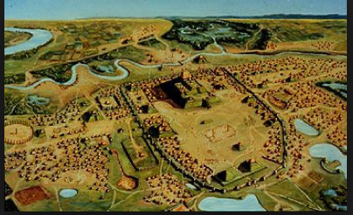
    - At its peak, the city spread for more than five square miles. The city center was Monk's Mound. Covering 14 acres at the base (covering more ground the largest Egyptian pyramid), it rises in terraces 10 stories high to a height of 100 feet. It is the largest prehistoric earthen structure in the "New World."
    - To build it, inhabitants hauled basket after basket of dirt on their backs, each weighing about 60 pounds. It is estimated that some 15 million trips were required to excavate, carry, and deposit the 22 million cubic feet of earth needed to build it. It probably took 300 years to build and was constructed between 900 and 1200.

