“The problem lay buried, unspoken.... It was a strange stirring, a sense of dissatisfaction, a yearning that women suffered in the middle of the twentieth century in the United States. Each suburban wife struggled with it alone. As she made the beds, shopped for groceries, matched slipcover material, ate peanut butter sandwiches with her children, chauffeured Cub Scouts and Brownies, lay beside her husband at night—she was afraid to ask even of herself the silent question—‘Is this all?’”
Betty Friedan, The Feminine Mystique

“Move on little girl; we have more important issues to talk about here than women’s liberation.”
MALE ANTIWAR ACTIVIST, Students for a Democratic Society (SDS)

“It makes you very sensitive—raw, even, this consciousness. Everything, from the verbal assault on the street, to a ‘well-meant’ sexist joke your husband tells, to the lower pay you get at work (for doing the same job a man would be paid more for), to television commercials, to rock-song lyrics, to the pink or blue blanket they put on your infant in the hospital nursery, to speeches by male ‘revolutionaries’ that reek of male supremacy—everything seems to barrage your aching brain.... You begin to see how all-pervasive a thing is sexism.”
—Robin Morgan, quoted in Sisterhood Is Powerful: An Anthology of Writings from the Women’s Liberation Movement
“The U.S. Constitution is not the place for symbols or slogans, it is not the proper device to alleviate psychological problems of personal inferiority. Symbols and slogans belong on bumper strips—not in the Constitution. It would be a tragic mistake for our nation to succumb to the tirades and demands of a few women who are seeking a constitutional cure for their personal problems.”
— Phyllis Schlafly, quoted in The Equal Rights Amendment: The History and the Movement

“Whatever your personal opinions and your insecurities about homosexuality and the various liberation movements among homosexuals and women (and I speak of the homosexuals and women as oppressed groups), we should try to unite with them in a revolutionary fashion. [...] I know through reading, and through my life experience and observations that homosexuals are not given freedom and liberty by anyone in the society. They might be the most oppressed people in the society. But whatever the case is, we know that homosexuality is a fact that exists, and we must understand it in its purest form: that is, a person should have the freedom to use his body in whatever way he wants.”
- Huey Newton, Black Panthers

Males do not represent two discrete populations, heterosexual and homosexual. The world is not to be divided into sheep and goats. Not all things are black nor all things white. It is a fundamental of taxonomy that nature rarely deals with discrete categories. Only the human mind invents categories and tries to force facts into separated pigeon-holes. The living world is a continuum in each and every one of its aspects. The sooner we learn this concerning human sexual behavior, the sooner we shall reach a sound understanding of the realities of sex.
-Alfred Kinsey “Sexual Behavior in the Human Male” (Published 1948)

Sexual harassment on the job is not a problem for virtuous women.
- Phyllis Schlafly

Since the women are the ones who bear the babies and there's nothing we can do about that, our laws and customs then make it the financial obligation of the husband to provide the support. It is his obligation and his sole obligation. And this is exactly and precisely what we will lose if the Equal Rights Amendment is passed.
- Phyllis Schlafly

It is easier to live through someone else than to complete yourself. The freedom to lead and plan your own life is frightening if you have never faced it before. It is frightening when a woman finally realizes that there is no answer to the question “who am I” except the voice inside herself.”
-Betty Friedan, The Feminine Mystique

Alfred Kinsey 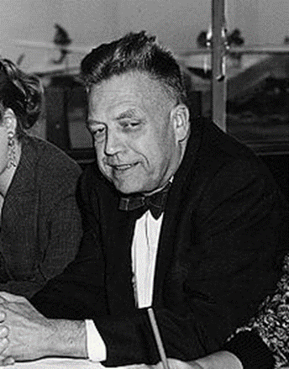
- Biologist, (Entymology, Zoology, Sexology), founded the Institute for Sex Research at Indiana University
- “Kinsey Reports”: A series of two published sexuality studies which provoked controversy. Some historians view these studies as a preview and logical basis for the later sexual revolution of the 1960s, which, in turn influenced the women’s liberation and gay liberation movements.
  - Sexual Behavior in the Human Male (1948)
  - Sexual Behavior in the Human Female (1953)
- The “Kinsey Scale”: developed by Kinsey and used in his research to describe a subject’s sexual orientation based on their responses to a questionnaire at a given time of life.

Kinsey’s scale, and his findings in his reports have since been repeatedly challenged by later researchers, but his work is still well known and provided a sound foundation for an important field of study.
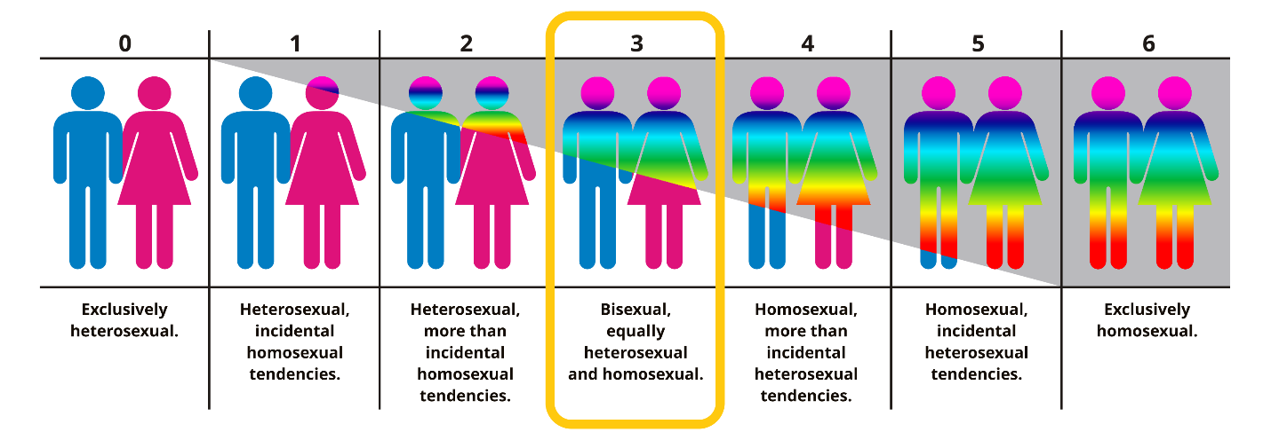

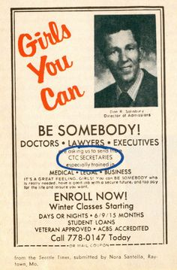

Before Stonewall, there was the Black Cat; LGBTQ leaders to mark 50th anniversary of protests at Silver Lake tavern

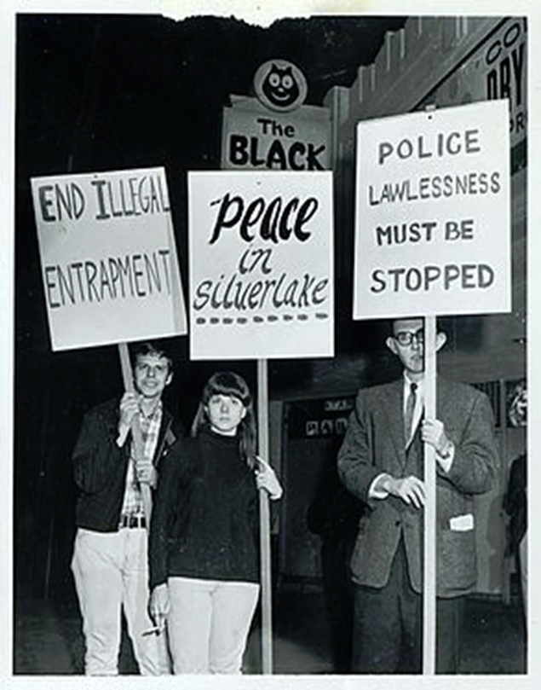

By: Hailey Branson Potts

Feb 8, 2017

Latimes.com
The clock had just struck midnight at the Black Cat tavern on Sunset Boulevard on New Year's Day 1967. As singers performed "Auld Lang Syne" in the Silver Lake bar, gay men kissed and embraced, celebrating the new year.
Unbeknownst to them, plainclothes Los Angeles police officers had positioned themselves in the crowd that night. They beat patrons and arrested 14 people, who were charged with lewd conduct for same-sex kissing. On Feb. 11, 1967, protesters took a bold step for that era and grabbed their picket signs, publicly protesting the police raid outside the bar — a gay-rights demonstration that pre-dated the monumental Stonewall riots in New York City by two years.

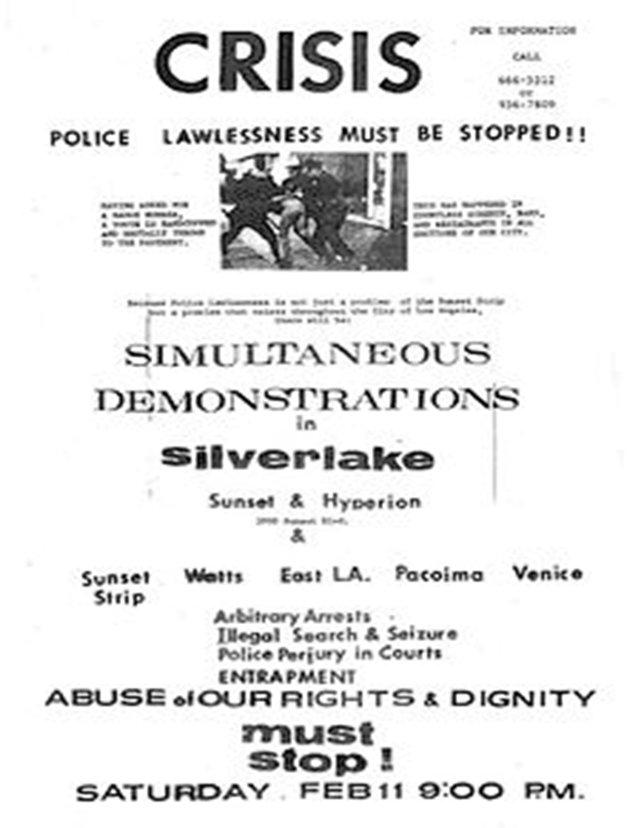

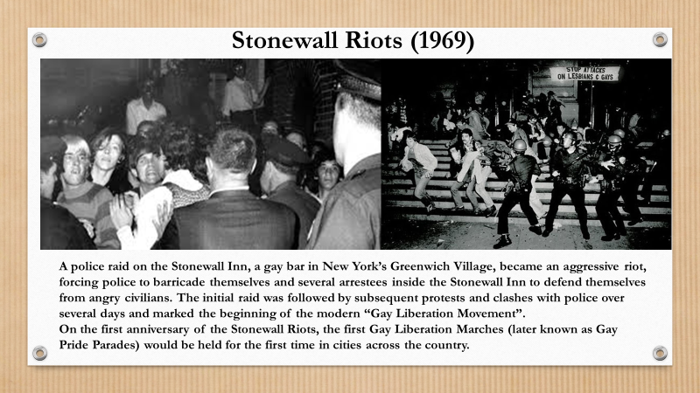
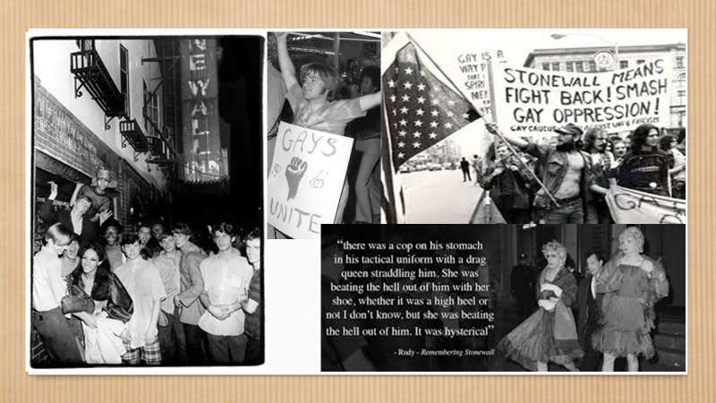
Fifty Years Ago, Protesters Took on the Miss America Pageant and Electrified the Feminist Movement
By Roxane Gay
SMITHSONIAN MAGAZINE
JANUARY 2018
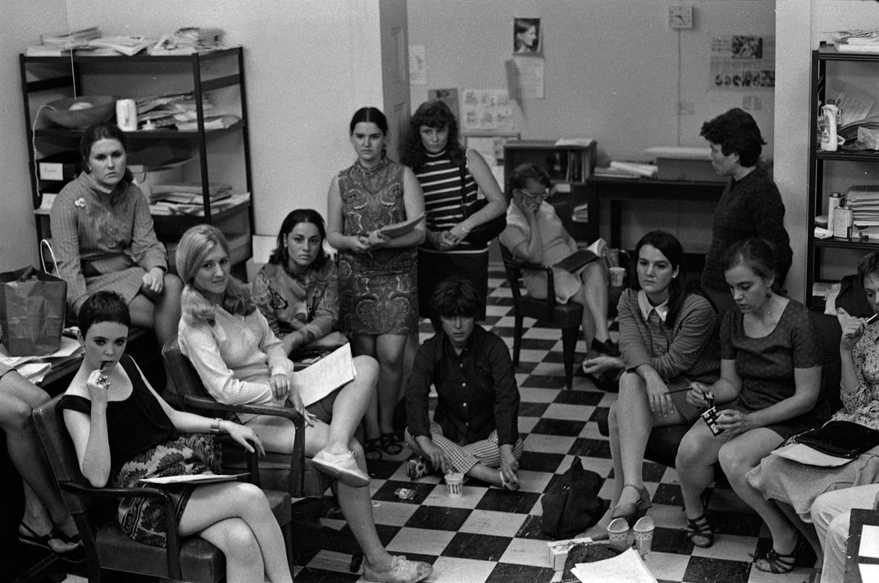
The Miss America pageant has never been a progressive event, but in 1968, it sparked a feminist revolution. As women organized the first protest against Miss America, they were responding not only to the pageant and its antiquated, misogynistic attitudes toward women and beauty, but also to how the United States, as a whole, treated women.
Since its inception, the pageant has evolved in some ways and not so much in others. The talent competition was introduced in 1938 so that perhaps the young women could be judged on more than just their appearance, but with that small bit of progress came regression. That same year, the pageant chose to limit eligibility to single, never-married women between the ages of 18 and 28. The kind of beauty the pageant wanted to reward was very specific and very narrow—that of the demure, slender-but-not-too-thin woman, the girl next door with a bright white smile, a flirtatious but not overly coquettish manner, smart but not too smart, certainly heterosexual. There was even a “Rule 7,” abandoned in 1940, that stated that Miss America contestants had to be “of good health and of the white race.”
On August 22, the New York Radical Women issued a press release inviting “women of every political persuasion” to the Atlantic City boardwalk on September 7, the day of the contest. They would “protest the image of Miss America, an image that oppresses women in every area in which it purports to represent us.” The protest would feature a “freedom trash can” into which women could throw away all the physical manifestations of women’s oppression, such as “bras, girdles, curlers, false eyelashes, wigs, and representative issues of Cosmopolitan, Ladies’ Home Journal, Family Circle, etc.” The organizers also proposed a concurrent boycott of companies whose products were used in or sponsored the pageant.
The organizers also issued a document offering ten reasons why they were protesting, with detailed explanations—a womanifesto, if you will. One contention was “the degrading Mindless-Boob-Girlie Symbol.” Another was racism, since a woman of color had never won—and there had never been a black contestant. “Nor has there ever been a true Miss America—an American Indian,” they wrote. They also protested the military-industrial complex and the role of Miss America as a “death mascot” in entertaining the troops. They pointed to the consumeristic nature of corporate sponsorship of the pageant and the valuing of beauty as a measure of a woman’s worth. The pageant represented the elevation of mediocrity—American women were encouraged to be “unoffensive, bland, apolitical”—and instilled this impoverished ambition in young girls. “NO MORE MISS AMERICA,” the womanifesto proclaimed.

