“The problem lay buried, unspoken.... It was a strange stirring, a sense of dissatisfaction, a yearning that women suffered in the middle of the twentieth century in the United States. Each suburban wife struggled with it alone. As she made the beds, shopped for groceries, matched slipcover material, ate peanut butter sandwiches with her children, chauffeured Cub Scouts and Brownies, lay beside her husband at night—she was afraid to ask even of herself the silent question—‘Is this all?’”
Betty Friedan, The Feminine Mystique

“Move on little girl; we have more important issues to talk about here than women’s liberation.”
MALE ANTIWAR ACTIVIST, SDS

“It makes you very sensitive—raw, even, this consciousness. Everything, from the verbal assault on the street, to a ‘well-meant’ sexist joke your husband tells, to the lower pay you get at work (for doing the same job a man would be paid more for), to television commercials, to rock-song lyrics, to the pink or blue blanket they put on your infant in the hospital nursery, to speeches by male ‘revolutionaries’ that reek of male supremacy—everything seems to barrage your aching brain.... You begin to see how all-pervasive a thing is sexism.”
—Robin Morgan, quoted in Sisterhood Is Powerful: An Anthology of Writings from the Women’s Liberation Movement
“The U.S. Constitution is not the place for symbols or slogans, it is not the proper device to alleviate psychological problems of personal inferiority. Symbols and slogans belong on bumper strips—not in the Constitution. It would be a tragic mistake for our nation to succumb to the tirades and demands of a few women who are seeking a constitutional cure for their personal problems.”
— Phyllis Schlafly, quoted in The Equal Rights Amendment: The History and the Movement

“Whatever your personal opinions and your insecurities about homosexuality and the various liberation movements among homosexuals and women (and I speak of the homosexuals and women as oppressed groups), we should try to unite with them in a revolutionary fashion. [...] I know through reading, and through my life experience and observations that homosexuals are not given freedom and liberty by anyone in the society. They might be the most oppressed people in the society. But whatever the case is, we know that homosexuality is a fact that exists, and we must understand it in its purest form: that is, a person should have the freedom to use his body in whatever way he wants.”
- Huey Newton, Black Panthers

Males do not represent two discrete populations, heterosexual and homosexual. The world is not to be divided into sheep and goats. Not all things are black nor all things white. It is a fundamental of taxonomy that nature rarely deals with discrete categories. Only the human mind invents categories and tries to force facts into separated pigeon-holes. The living world is a continuum in each and every one of its aspects. The sooner we learn this concerning human sexual behavior, the sooner we shall reach a sound understanding of the realities of sex.
-Alfred Kinsey “Sexual Behavior in the Human Male” (Published 1948)

Sexual harassment on the job is not a problem for virtuous women.
- Phyllis Schlafly

Since the women are the ones who bear the babies and there's nothing we can do about that, our laws and customs then make it the financial obligation of the husband to provide the support. It is his obligation and his sole obligation. And this is exactly and precisely what we will lose if the Equal Rights Amendment is passed.
- Phyllis Schlafly

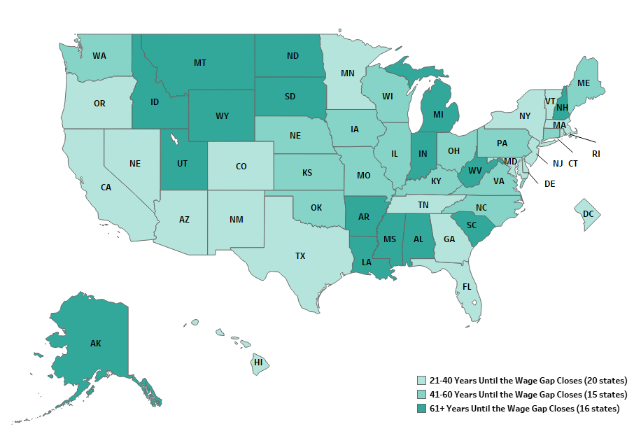
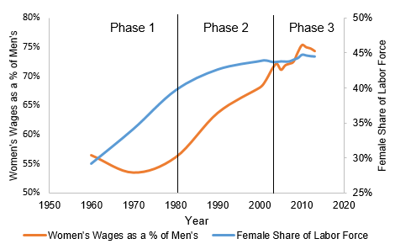
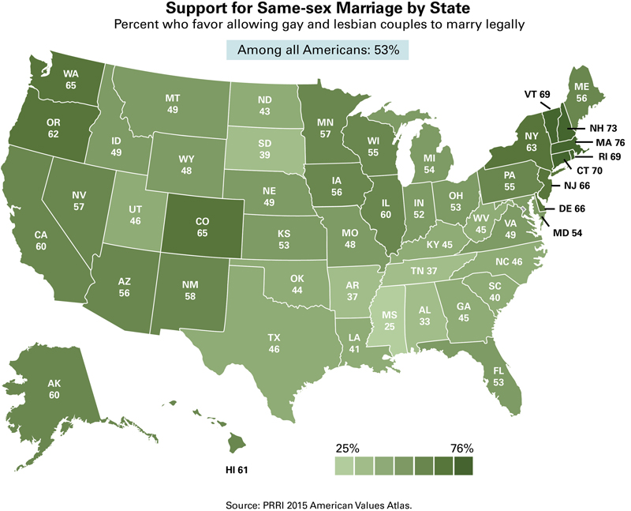
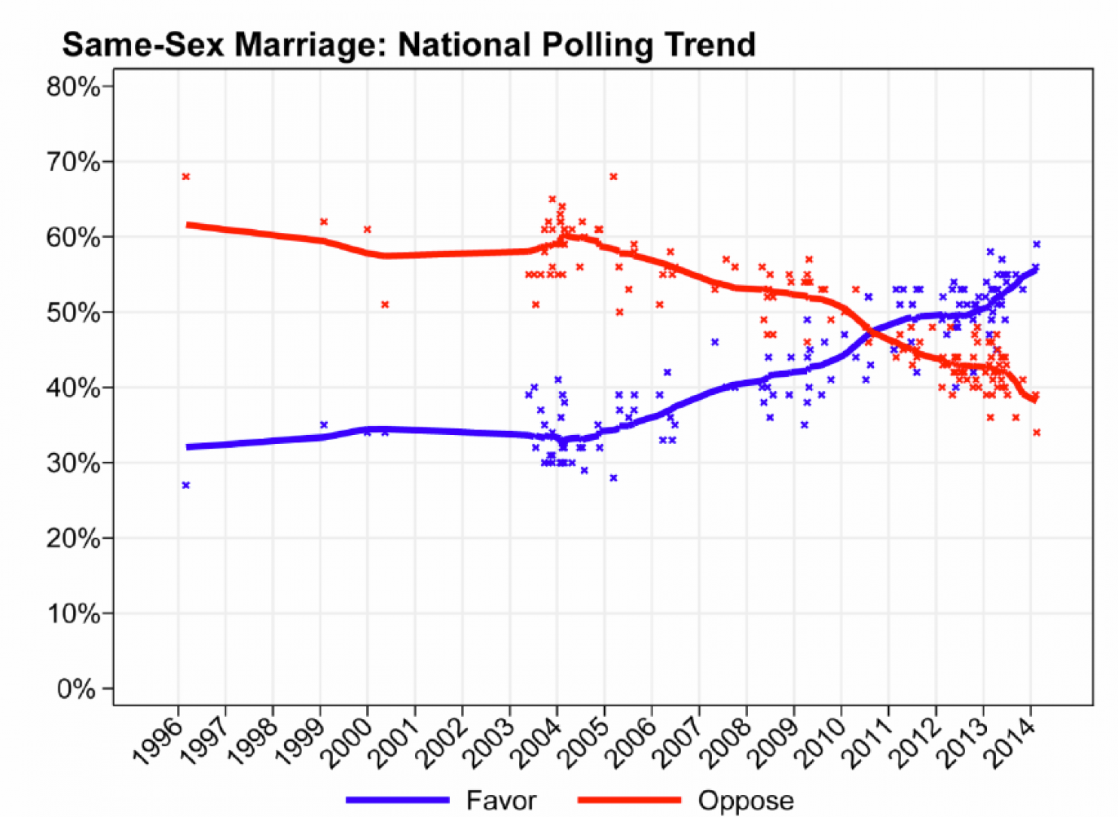

AN OUTLINE OF IMPERATIVES FOR GAY LIBERATION
1. Free ourselves: “come out” everywhere; initiate self-defense and political activity; initiate counter-community institutions.
2. Turn other gay people on: talk all the time; understand, forgive, accept.
3. Free the homosexual in everyone: we’ll be getting a good bit of sh$% from threatened latents: be gentle, and keep talking & acting free.
4. We’ve been playing an act for a long time, so we’re consummate actors. Now we can begin to be, and it’ll be a good show!

