Facebook’s fake news problem: What’s its responsibility?

BY BARBARA ORTUTAY 11.15.2016 NEWS > US
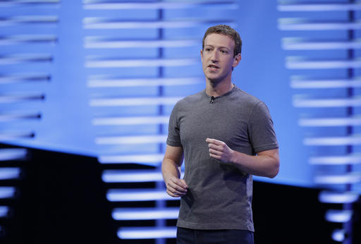
NEW YORK (AP) — Facebook is under fire for failing to rein in fake and biased news stories that some believe may have swayed the presidential election. Its predicament stems from this basic conundrum: It exercises great control over the news its users see, but it declines to assume the editorial responsibility that traditional publishers do.
On Monday, Facebook took a minor step to address the issue, clarifying its advertising policy to emphasize that it won’t display ads on sites that run information that is “illegal, misleading or deceptive, which includes fake news.” The company said it was merely making explicit a policy that was already implied.
Its move followed a similar step by Google earlier on Monday, after the search giant acknowledged that it had let a false article about the election results slip into its list of recommended news stories.
In the case of both companies, the aim is to discourage fake-news sites by depriving them of revenue.
Facebook is also said to be facing brewing internal turmoil over its influence and what it can and should do about it.
Employees have expressed concern over Facebook’s role in spreading misinformation and racist memes largely associated with the alt-right, according to The New York Times and BuzzFeed. Some have reportedly formed an unofficial task force to investigate the role the company played in the election.
Founder and CEO Mark Zuckerberg, however, insists that Facebook remains a neutral technology platform where its users can share anything they want, with only a tiny fraction of it fake or problematic.
Last week, Zuckerberg called the idea that voters might have been influenced by what they saw on Facebook — fake, uber-partisan stories, such as a false one about Pope Francis endorsing Donald Trump for president — “pretty crazy.”
FACEBOOK CONTROL
People update to Facebook so frequently that the company has no choice but to filter what everyone sees in their news feeds — the main artery through which users see posts from their friends, family, businesses, news sources and celebrities they follow.
The company’s secret algorithms are designed to deliver the posts from friends and other sources that will draw people in and lead them to read and click and “like” and share — “maximizing their engagement,” in Facebook’s jargon.
Facebook frequently tweaks its algorithm to improve engagement. Various changes have been aimed at shutting out sites that promote clickbait and other garbage that users say they don’t want to see, even as they click on it and share away. When users are surrounded by posts they want to see, they’re more likely to stick around.
That’s key to Facebook’s advertising business. But it can be problematic when it comes to false but highly interesting posts.
Facebook’s news feed “maximizes for engagement. As we’ve learned in this election, bulls–t is highly engaging,” former Facebook product designer Bobby Goodlatte wrote in an Election Day post. “Highly partisan, fact-light outlets” on both the right and the left, he wrote, “have no concern for the truth, and really only care for engagement. … It’s now clear that democracy suffers if our news environment incentivizes bulls–t.”
Social media companies today have to acknowledge that they are news organizations, said Jeffrey Herbst, president and CEO of the Newseum, a journalism museum in Washington. “Not like news companies of the 20th century,” he added. “But not just pipes where people get their news. They determine what is news.”
In a post Saturday night, Zuckerberg rejected that idea.
“News and media are not the primary things people do on Facebook, so I find it odd when people insist we call ourselves a news or media company in order to acknowledge its importance,” he wrote. “Facebook is mostly about helping people stay connected with friends and family.”
FACEBOOK AS NEWSPAPER — NO, SCRATCH THAT
Back in 2013, Zuckerberg said he wanted Facebook to be people’s “own personal newspaper,” one that delivers the stories most interesting and important to them. That’s still the company’s goal — though minus any reference to itself as a media company of any kind.
Of course, fake stuff has existed on the internet long before Facebook. And under the law, Facebook is no more responsible for what appears on its site than “the paper mills that print newspapers are responsible for their content,” said Steve Jones, a professor at the University of Illinois at Chicago who studies communication technology.
At the same time, Jones said he thinks the broader issue of Facebook’s responsibility is one that’s going to be “debated forever.”
“Even the notion of truth is something that’s highly contested at this point,” he said.
Reflection Questions:
- Make connections or comparisons between the news shared on Facebook regarding the 2016 election, and the yellow journalism engaged in by Hearst and Pulitzer prior to the Spanish American War.

- Do you agree or disagree that Facebook is a “news service”? As such, what kind of journalistic responsibility (if any) do you think Facebook should be taking for the news that it collates and allows to be shared on its platform? Do they have the same sort of journalistic responsibility that was expected of Hearst and Pulitzer during the Spanish American War? Comment on the nature and details of that responsibility.

- For 5 EXTRA CREDIT points! Conduct research to collect an article published in either Hearst’s or Pulitzer’s newspapers in early 1898, and use it to help construct your reflection. Please submit a copy of this primary source along with your reflection paper when you hand in your homework on Friday.

